Clickstream

E-commerce Conversion Funnel Analysis — Project Report

HEMARAJ P
(Individual Project)

1 Executive Summary (Top-Level Takeaway)
A detailed clickstream analysis reveals that while overall user engagement is strong across global markets like UK, India, and Australia, there are noticeable drop-offs before add‑to‑cart, especially on mobile devices. Optimizing engagement and checkout experiences can significantly improve conversion rates.

2 Objective / Business Question
Clearly understand user behavior through the conversion funnel and answer: > “Where do users drop off most, and how can we increase the purchase conversion rate?”

3 Key Metrics / KPIs
- Total Sessions
- Conversion Rate %
- Add-to-Cart Rate
- Avg Time on Page (Engagement)
- Sessions by Device Type / Country

4 Insights & Findings
What we found (Fact) | Why it matters (Interpretation) | Action Recommendation
High Time on Page correlates with higher add‑to‑cart | Engagement drives purchase intent | Add personalized product suggestions
Major drop‑off after Product View stage | Lack of persuasion to add item | Strong CTAs and limited‑time offers
Mobile users convert less than desktop | Checkout difficulty on mobile | Mobile checkout optimization
UK, India, Australia show higher engagement | Focus markets with high ROI opportunity | Targeted marketing here

5 Supporting Visuals
- Conversion Funnel Dashboard
- Drill‑through Session Behavior Page
- Country Map Visual
(Visual screenshots in Appendix)

6 Limitations (Optional but Crisp)
- Dataset size is limited
- Revenue/product category data missing
- No user persona segmentation available

7 Next Steps / Recommendations
- Implement A/B testing on CTA & homepage layout
- Personalized recommendations to improve engagement
- Fix mobile UX issues to boost mobile conversion
- Marketing focus on high‑engagement countries
Don’t dump analysis — deliver decisions. Stakeholders need: What happened? Why? What should we do?

8 Conclusion
This project analyzes user behavior on an e-commerce platform using clickstream data. The goal is to understand how users navigate through different website pages and identify patterns that lead to product purchase or drop-offs.
Dataset includes: - SessionID - UserID - Timestamp - PageType - DeviceType - Country - ReferralSource - TimeOnPage_seconds - ItemInCart - Purchased

2 Business Problem we are Solving
Many users visit the website, but only a small percentage convert into buyers. The business wants to: - Improve engagement - Reduce drop-offs - Increase purchase conversion rate
This analysis helps stakeholders understand where users drop off and how to improve funnel performance.

3 Key KPIs (from Dashboard)
KPI | Description
Total Sessions | Count of unique Session IDs
Average Time Spent | Engagement measure
Conversion Rate % | Users who completed purchase
Add-to-Cart Rate | Users showing buying intent
Funnel Stages: 1. Page Visit 2. Product View 3. Add to Cart 4. Purchase

4 Dashboard Insights (High-level Summary)
- Countries such as UK, India & Australia show strong engagement.
- High Time On Page is correlated with higher add-to-cart probability.
- Desktop users tend to convert more than mobile users.
- Sessions with Product View but no Cart are major drop-off points.

5 Drill-through Analysis
A detailed drill-through page shows: - Session-level interactions - Engagement by timestamp - Country map visuals to identify geo trends
This helps understand individual customer behavior and journey analytics.

6 Limitations
- Data only includes session-level logs; user lifetime metrics missing
- Small dataset may not reflect real business scale
- Product categories and pricing not available

7 Recommendations
- Implement Personalized Homepage to reduce early drop-offs
- Enable Product recommendations for better engagement
- Improve Mobile checkout flow to increase mobile conversion
- Introduce A/B testing on CTAs and add‑to‑cart buttons
Golden Rule: Don’t just dump data – Deliver business decisions 💡

8 Conclusion
The clickstream dashboard provides clear visibility into the customer funnel and highlights where improvements can significantly increase conversions.
This analysis empowers the business to make data-driven decisions that enhance user engagement and revenue.

Appendix
Screenshots of dashboard pages included: - Main Funnel Page - Drill-Through Session Page
Main Funnel Page:

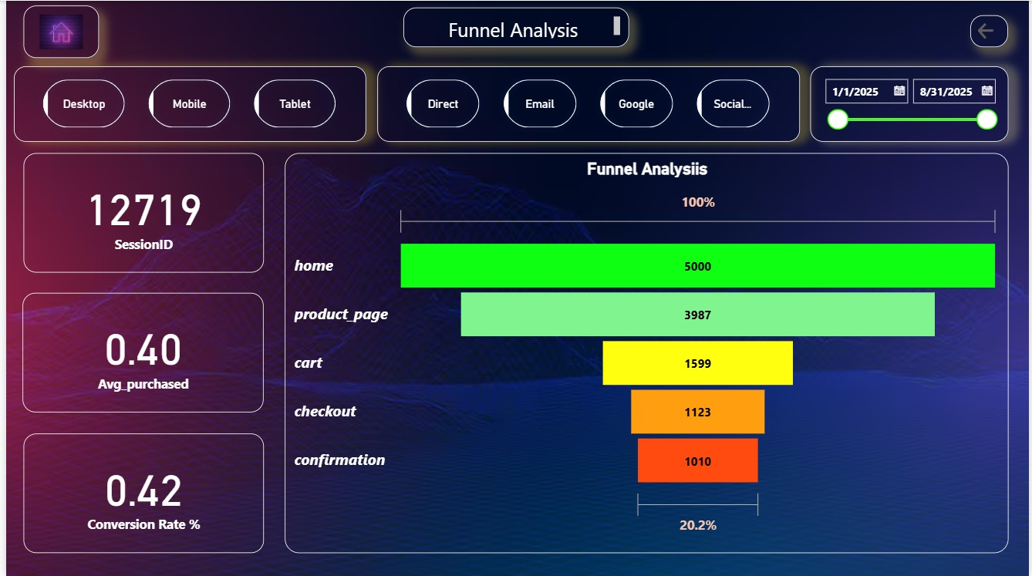

Traffic Source Analysis:
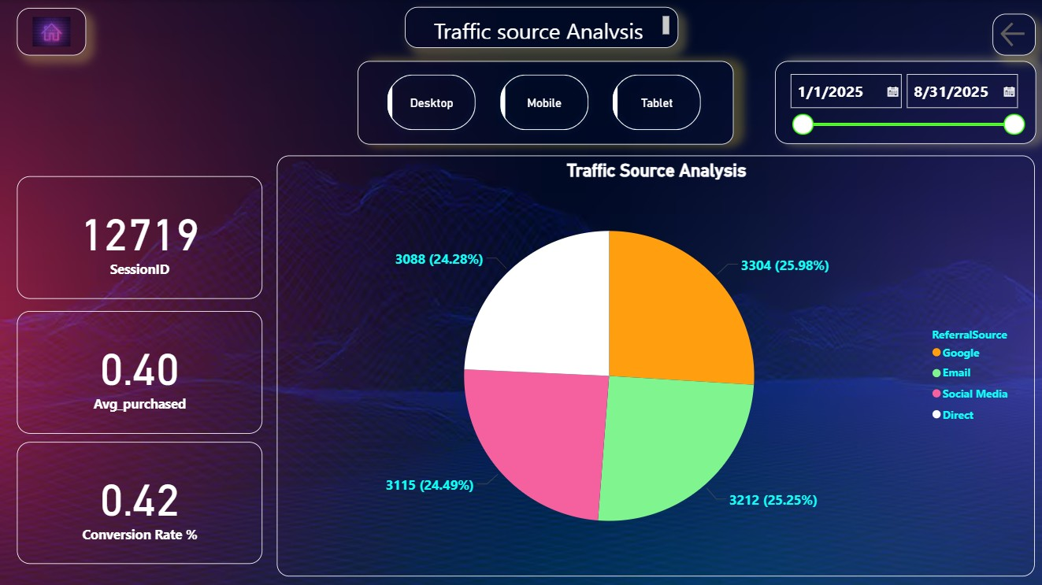

Drill through Page:
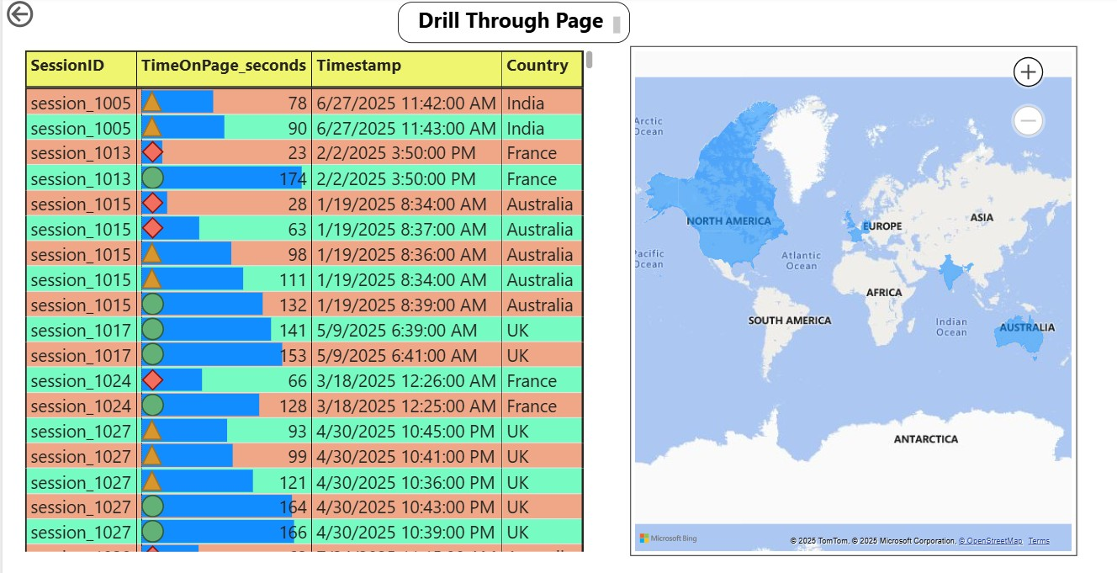
Data Modelling Page:

